Set up Outlook for Microsoft 365 for business email

There are several ways that this document can be used. Below are the options. Please select the setup you require.
Prerequisites
- An M365 license and mailbox
- A computer or mobile device
- Your user credentials

Create a new Outlook profile connected to Microsoft 365 email (Windows)
- In Microsoft Windows, click the 'Control Panel' button in the bottom left.
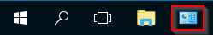

- Click 'Mail (32-Bit)' to open the Mail Profile Settings.
Note: If you do not have the 'Mail (32-bit)' shortcut, please install Outlook
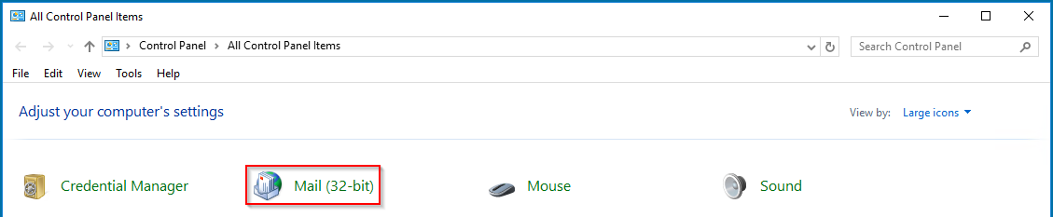

- In the following pop-up, click 'Add...' to create a new email profile to point to Office 365 servers
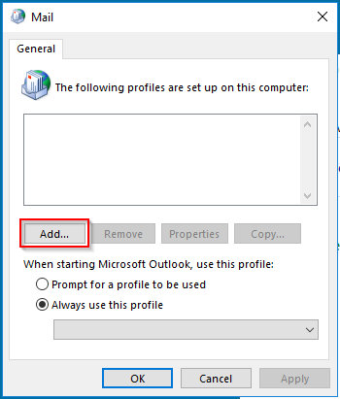
Please make sure to tick ‘Always use this profile’
- Name your profile. We recommend a name like 'Office365,' or something that will help you and Impact Support know that this is and Office 365 profile. Then, click 'OK.'
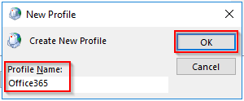
- You will be asked for your name, email address, your password, and a password confirmation. Fill in the information, then click 'Next.'
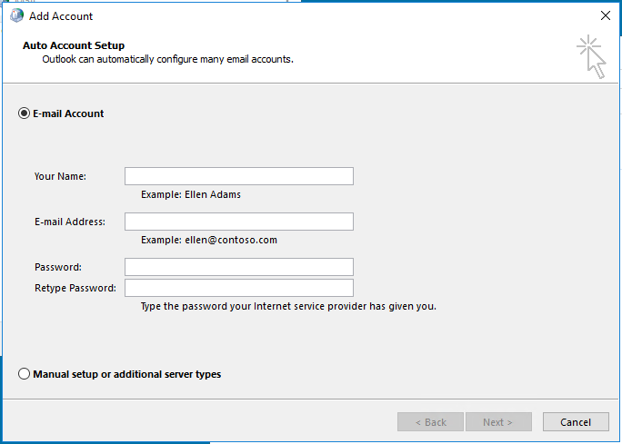
- Auto Discover will find your server settings and auto connect you to your mailbox. Once the mailbox has been linked, you may be asked to confirm your settings again. It is recommended that you check the box labeled 'Save this password in your password list,' otherwise you will be asked to provide your password whenever you open Microsoft applications. Then, click 'OK.'
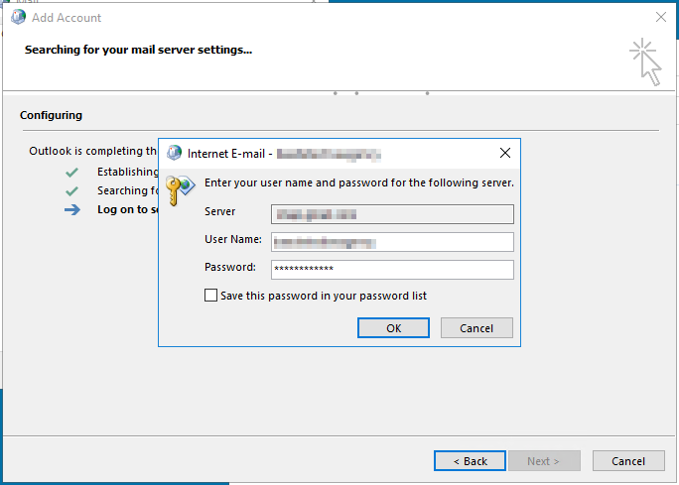
- Click 'Finish' once the account has been setup
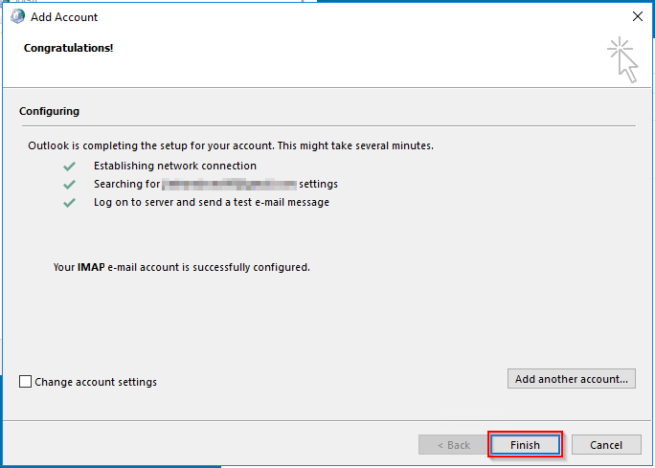
**Important Note:** Before exiting the Mail settings, click on the drop-down menu beneath 'Always use this profile' and double-check that the profile you just created is the one that is active. Then, click 'Apply.'
When you launch Outlook, you will be brought to your Office365 mailbox.

Add my Microsoft 365 email to Outlook (Windows)
Add your Microsoft 365 email to Outlook 2016 (or newer) for Windows PC. Then you can send and receive business emails.
- Open Outlook. (Don't have the app? Here's how to download it.)
- Select File, and then select + Add Account.
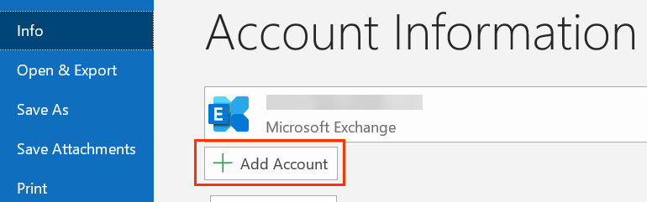
If you haven't opened Outlook before, you'll see a welcome screen.
- Enter your Microsoft 365 Email address and select Connect.
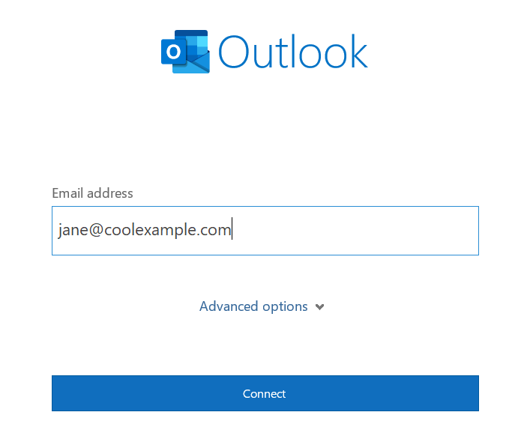
- Enter your Microsoft 365 Password and select Sign In. If asked, choose if you want to use this account everywhere on your device.
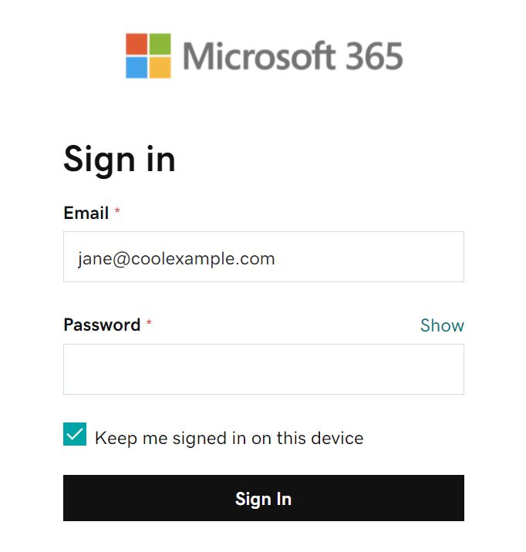
Note: You might need to choose your account type as Work or School to continue.
- Once Outlook shows that the email was added, select Done.

Add my Microsoft 365 email to Mail (Windows)
Add your Microsoft 365 account to the Mail app for Windows so you can send and receive business email.
- From the Start menu, open Mail.
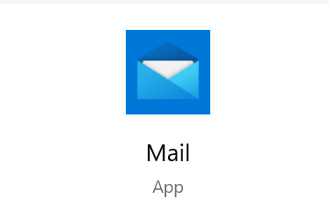
- If you've used the app before, select  Settings, and then choose Manage Accounts. Otherwise, continue to the next step.
- Select Add account.
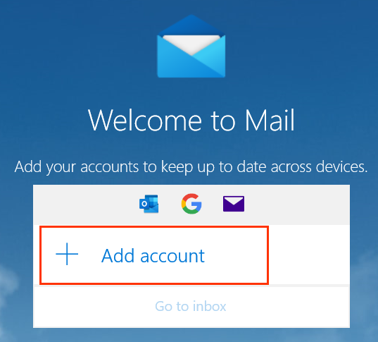
- Select Office 365.
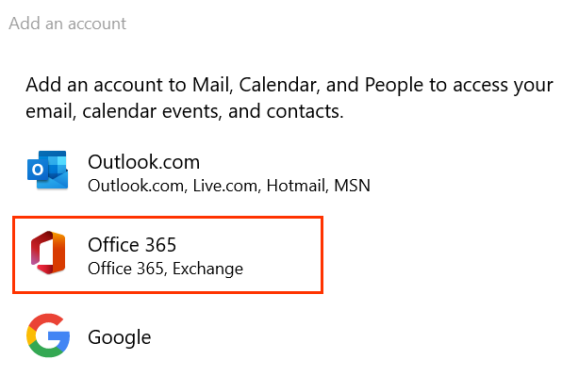
- Enter your Microsoft 365 Email address, and then select Next.
- Select Work or school account, and then select Continue.
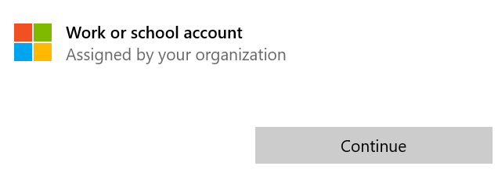
- Enter your Microsoft 365 email address and password, and then select Sign In.
Note: You might need to choose if you want Windows to remember your account, or if you only want to sign in to the Mail app.
- After you see that your accounts set up, select Done to go to your inbox.

Add my Microsoft 365 email to Outlook (Mac)
- Open Outlook. (Don't have the app? Here's how to download it.)
- From the menu bar, select Outlook > Preferences.
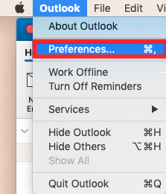
- Select Accounts.
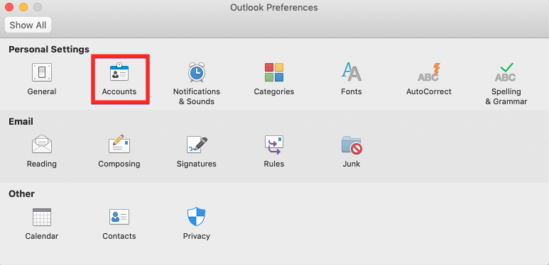
- Select + (plus) > New account.
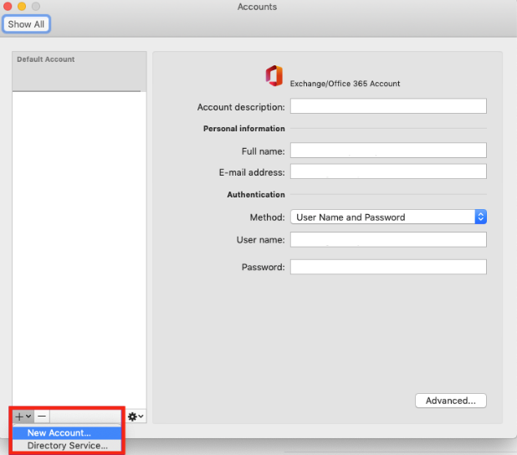
Note: You might need to choose your account type as Work/School to continue.
- Enter your email address and select Continue.
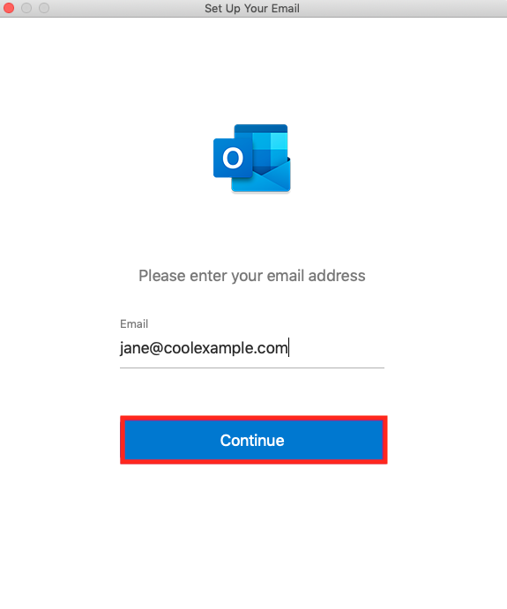
- Enter your email password and select Sign in.
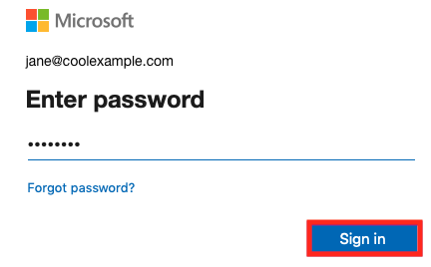
- Select Done. If you have more than one account, decide which account you want to set as the default.
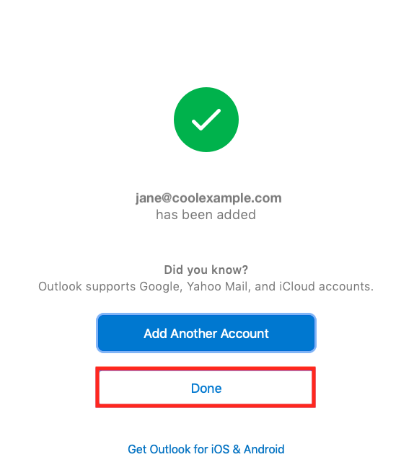
Your account will display, and your email will load, which can take a few minutes.

Add my Microsoft 365 email to Mail on iPhone or iPad
Note: We recommend using the Outlook app for iOS. To get Outlook, use your phone's camera to scan this QR code.

Add your Microsoft 365 email to the Mail app on your iPhone or iPad. Then you can send, receive, and organize emails.

- Open your iPhone or iPad's Settings.
- Tap Mail > Accounts. (Depending on your iOS version, you might need to tap Passwords & Accounts.)
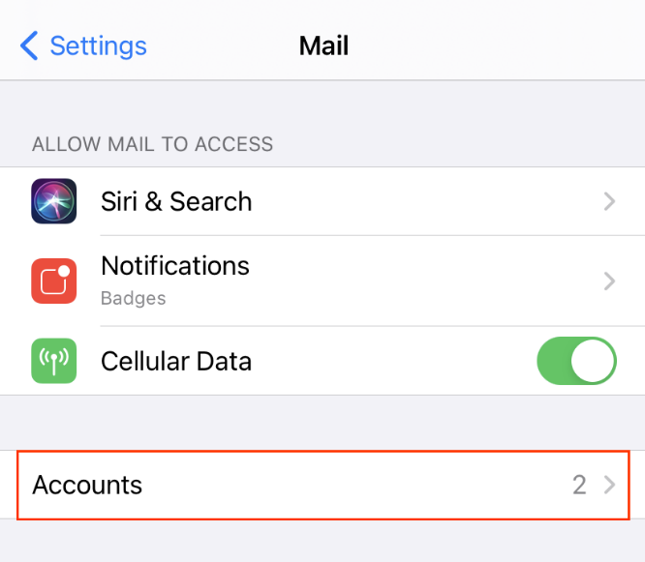
- Tap Add Account.
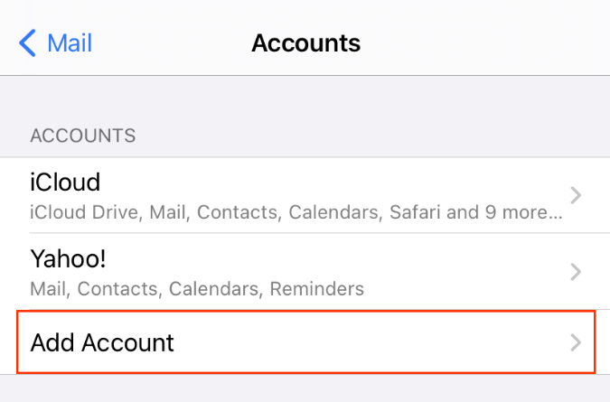
- Tap Microsoft Exchange.
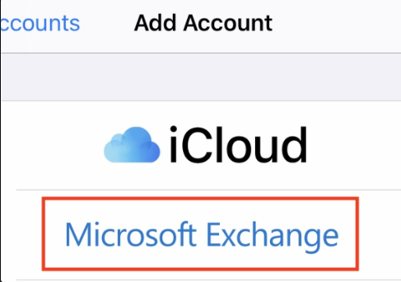
- Enter your Email and a short Description (like your company's name or email type), and then tap Next.
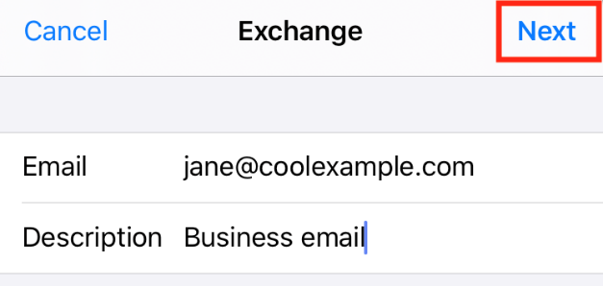
- Tap Sign In to confirm you want to use your Microsoft Exchange account.
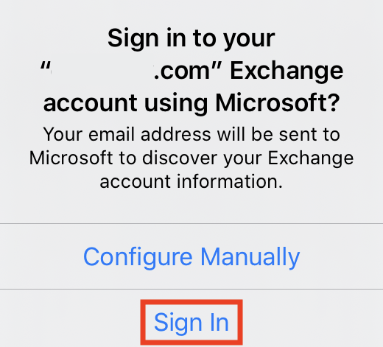
- Enter your Password and tap Sign In. (You might need to select your account type as Work or school, not Personal, to continue.)

Note: If Microsoft can't find your account, you might be asked to enter your details manually:
• Email: Your Microsoft 365 email address
• Password: Your Active Directory password
• Server: outlook.office365.com (this is required)
• Domain: This can be left empty
• Username: Your Microsoft 365 email address
- Tap Next. You might be asked to select Consent on behalf of your organization. This allows Microsoft 365 and the Mail app to work together. Tap Accept.
- Tap Save. You can come back and update settings here at any point.
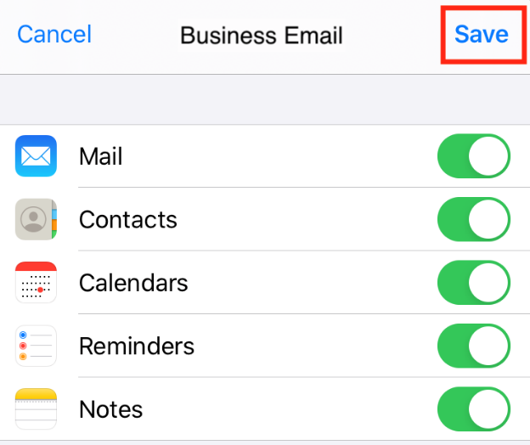
- That's it! You'll see your Microsoft 365 account under Accounts.
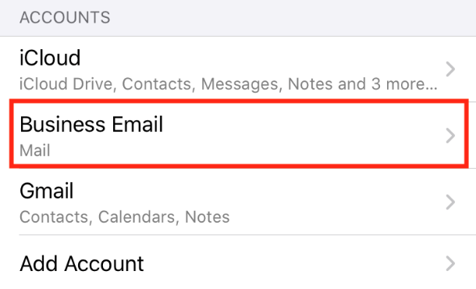

Add my Microsoft 365 email to Outlook on iPhone or iPad
Add your Microsoft 365 email to Outlook for iPhone and iPad. Then you can send and receive emails wherever you are.

Required: Before continuing, make sure you have the Outlook app. To download Outlook, use your phone's camera to scan this QR code.

- Open Outlook. (If you just downloaded the app, tap Get started, choose your preferences, and then go to step 4.)
- Tap Menu, then  Settings.
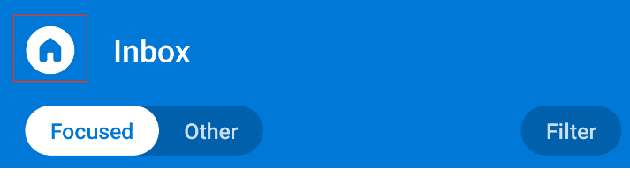
- Tap Add Mail Account, then Add Email Account.
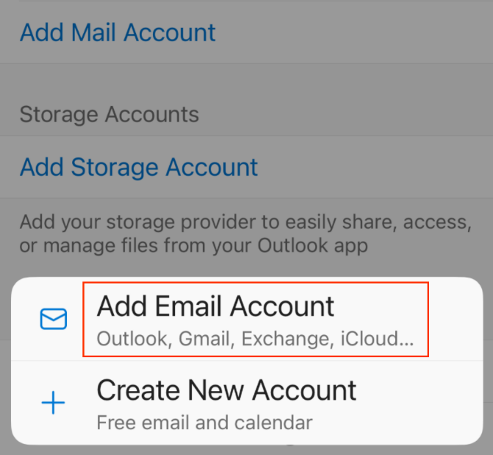
- Enter your Microsoft 365 email address, and then tap Add Account.
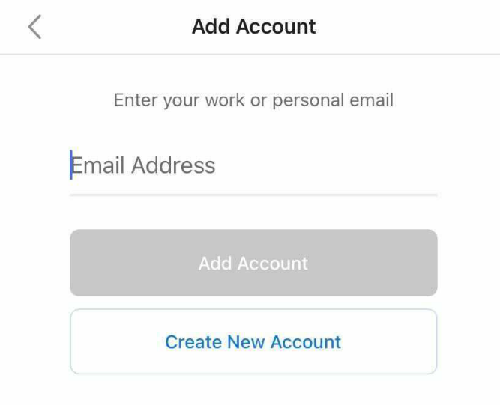
- Enter your Active Directory password, and then tap Sign In. (You might need to choose your account type as Work or school, not Personal, to continue.)

- Your Microsoft 365 account will show in Settings. Go to your Inbox to check your email.
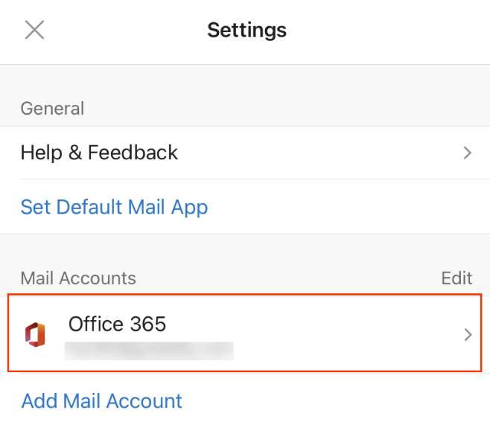

Add my Microsoft 365 email to Outlook on Android

Add your Microsoft 365 email account to Outlook for Android. You can send and receive business emails from your phone, never missing a beat.

Required: Before continuing, make sure you have the Outlook app. To download Outlook, use your phone's camera to scan this QR code.

- Open Outlook.
- Tap Menu, then  Settings.
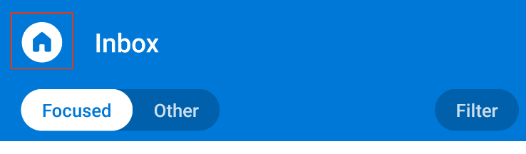
- Tap Add Mail Account, then Add an email account.
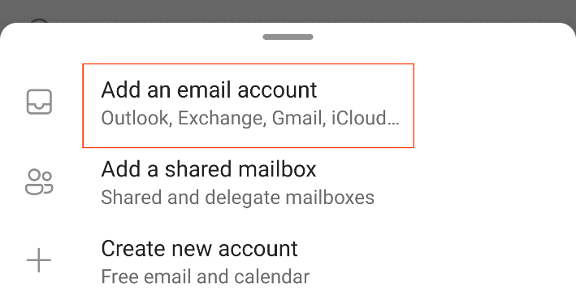
- Enter your Microsoft 365 email address and tap Continue.
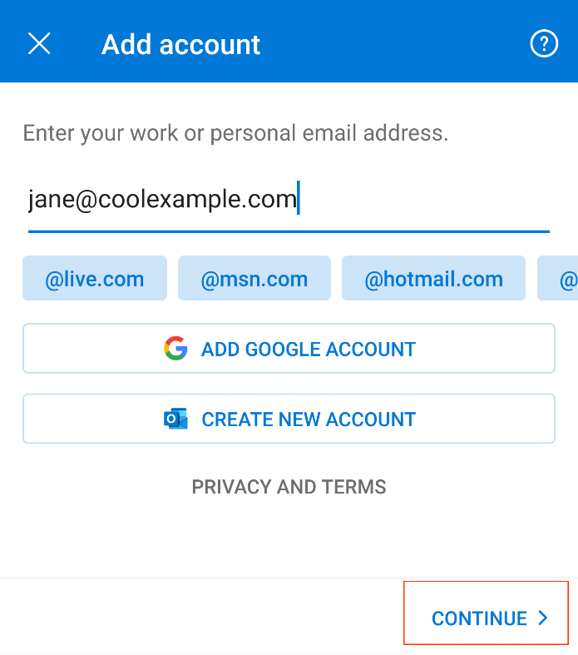
- Enter your Active Directory password and tap Sign In. (You might need to choose your account type as Work or School, not Personal, to continue.)

- Your Microsoft 365 account now shows in Settings. Go to your Inbox to check your email.
